# Get started with data science in Microsoft Fabric

In this lab, you’ll ingest data, explore the data in a notebook, process the data with the Data Wrangler, and train two types of models. By performing all these steps, you’ll be able to explore the data science features in Microsoft Fabric.

By completing this lab, you’ll gain hands-on experience in machine learning and model tracking, and learn how to work with *notebooks*, *Data Wrangler*, *experiments*, and *models* in Microsoft Fabric.

This lab will take approximately **20** minutes to complete.

**Note**: You need a [Microsoft Fabric trial](https://learn.microsoft.com/fabric/get-started/fabric-trial) to complete this exercise.

Create a workspace

Before working with data in Fabric, create a workspace with the Fabric trial enabled.

1. Navigate to the [Microsoft Fabric home page](https://app.fabric.microsoft.com/home?experience=fabric) at https://app.fabric.microsoft.com/home?experience=fabric in a browser.
2. Select **Synapse Data Science**.
3. In the menu bar on the left, select **Workspaces** (the icon looks similar to 🗇).
4. Create a new workspace with a name of your choice, selecting a licensing mode that includes Fabric capacity (*Trial*, *Premium*, or *Fabric*).
5. When your new workspace opens, it should be empty.

[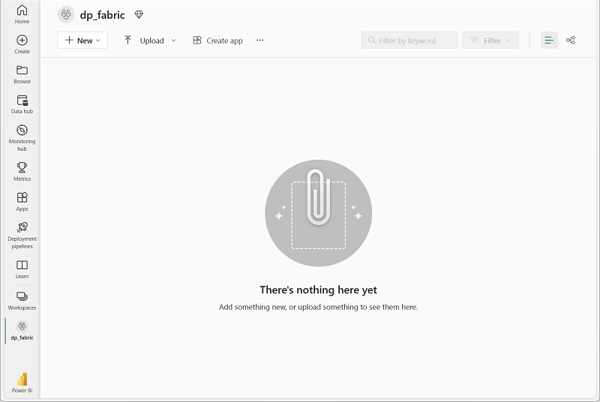](https://microsoftlearning.github.io/mslearn-fabric/Instructions/Labs/Images/new-workspace.png)

Create a notebook

To run code, you can create a *notebook*. Notebooks provide an interactive environment in which you can write and run code (in multiple languages).

1. In the **Synapse Data Science** home page, create a new **Notebook**.

After a few seconds, a new notebook containing a single *cell* will open. Notebooks are made up of one or more cells that can contain *code* or *markdown* (formatted text).

1. Select the first cell (which is currently a *code* cell), and then in the dynamic tool bar at its top-right, use the **M↓** button to convert the cell to a *markdown* cell.

When the cell changes to a markdown cell, the text it contains is rendered.

1. Use the **🖉** (Edit) button to switch the cell to editing mode, then delete the content and enter the following text:

codeCopy

# Data science in Microsoft Fabric

Get the data

Now you’re ready to run code to get data and train a model. You’ll work with the [diabetes dataset](https://learn.microsoft.com/azure/open-datasets/dataset-diabetes?tabs=azureml-opendatasets?azure-portal=true) from the Azure Open Datasets. After loading the data, you’ll convert the data to a Pandas dataframe: a common structure for working with data in rows and columns.

1. In your notebook, use the **+ Code** icon below the latest cell output to add a new code cell to the notebook.

**Tip**: To see the **+ Code** icon, move the mouse to just below and to the left of the output from the current cell. Alternatively, in the menu bar, on the **Edit** tab, select **+ Add code cell**.

1. Enter the following code in the new code cell:

codeCopy

# Azure storage access info for open dataset diabetes

blob_account_name = "azureopendatastorage"

blob_container_name = "mlsamples"

blob_relative_path = "diabetes"

blob_sas_token = r"" # Blank since container is Anonymous access

# Set Spark config to access blob storage

wasbs_path = f"wasbs://%s@%s.blob.core.windows.net/%s" % (blob_container_name, blob_account_name, blob_relative_path)

spark.conf.set("fs.azure.sas.%s.%s.blob.core.windows.net" % (blob_container_name, blob_account_name), blob_sas_token)

print("Remote blob path: " + wasbs_path)

# Spark read parquet, note that it won't load any data yet by now

df = spark.read.parquet(wasbs_path)

1. Use the **▷ Run cell** button on the left of the cell to run it. Alternatively, you can press SHIFT + ENTER on your keyboard to run a cell.

**Note**: Since this is the first time you’ve run any Spark code in this session, the Spark pool must be started. This means that the first run in the session can take a minute or so to complete. Subsequent runs will be quicker.

1. Use the **+ Code** icon below the cell output to add a new code cell to the notebook, and enter the following code in it:

codeCopy

display(df)

1. When the cell command has completed, review the output below the cell, which should look similar to this:

| AGE | SEX | BMI | BP | S1 | S2 | S3 | S4 | S5 | S6 | Y |
| --- | --- | --- | --- | --- | --- | --- | --- | --- | --- | --- |
| 59 | 2 | 32.1 | 101.0 | 157 | 93.2 | 38.0 | 4.0 | 4.8598 | 87 | 151 |
| 48 | 1 | 21.6 | 87.0 | 183 | 103.2 | 70.0 | 3.0 | 3.8918 | 69 | 75 |
| 72 | 2 | 30.5 | 93.0 | 156 | 93.6 | 41.0 | 4.0 | 4.6728 | 85 | 141 |
| 24 | 1 | 25.3 | 84.0 | 198 | 131.4 | 40.0 | 5.0 | 4.8903 | 89 | 206 |
| 50 | 1 | 23.0 | 101.0 | 192 | 125.4 | 52.0 | 4.0 | 4.2905 | 80 | 135 |
| … | … | … | … | … | … | … | … | … | … | … |

1. The output shows the rows and columns of the diabetes dataset.
2. There are two tabs at the top of the rendered table: **Table** and **Chart**. Select **Chart**.
3. Select the **Customize chart** at the right top of the chart to change the visualization.
4. Change the chart to the following settings:
   * **Chart Type**: Box plot
   * **Key**: *Leave empty*
   * **Values**: Y
5. Select **Apply** to render the new visualization and explore the output.

Prepare the data

Now that you have ingested and explored the data, you can transform the data. You can either run code in a notebook, or use the Data Wrangler to generate code for you.

1. The data is loaded as a Spark dataframe. While the Data Wrangler accepts either Spark or Pandas dataframes, it is currently optimized to work with Pandas. Therefore, you will convert the data to a Pandas dataframe. Run the following code in your notebook:

codeCopy

df = df.toPandas()

df.head()

1. Select **Data Wrangler** in the notebook ribbon, and then select the df dataset. When Data Wrangler launches, it generates a descriptive overview of the dataframe in the **Summary** panel.

Currently, the label column is Y, which is a continuous variable. To train a machine learning model that predicts Y, you need to train a regression model. The (predicted) values of Y may be difficult to interpret. Instead, we could explore training a classification model which predicts whether someone is low risk or high risk for developing diabetes. To be able to train a classification model, you need to create a binary label column based on the values from Y.

1. Select the Y column in the Data Wrangler. Note that there is a decrease in frequency for the 220-240 bin. The 75th percentile 211.5 roughly aligns with transition of the two regions in the histogram. Let’s use this value as the threshold for low and high risk.
2. Navigate to the **Operations** panel, expand **Formulas**, and then select **Create column from formula**.
3. Create a new column with the following settings:
   * **Column name**: Risk
   * **Column formula**: (df['Y'] > 211.5).astype(int)
4. Review the new column Risk that is added to the preview. Verify that the count of rows with value 1 should be roughly 25% of all rows (as it’s the 75th percentile of Y).
5. Select **Apply**.
6. Select **Add code to notebook**.
7. Run the cell with the code that is generated by Data Wrangler.
8. Run the following code in a new cell to verify that the Risk column is shaped as expected:

codeCopy

df_clean.describe()

Train machine learning models

Now that you’ve prepared the data, you can use it to train a machine learning model to predict diabetes. We can train two different types of models with our dataset: a regression model (predicting Y) or a classification model (predicting Risk). You’ll train the models using the scikit-learn library and track the models with MLflow.

Train a regression model

1. Run the following code to split the data into a training and test dataset, and to separate the features from the label Y you want to predict:

codeCopy

from sklearn.model_selection import train_test_split

X, y = df_clean[['AGE','SEX','BMI','BP','S1','S2','S3','S4','S5','S6']].values, df_clean['Y'].values

X_train, X_test, y_train, y_test = train_test_split(X, y, test_size=0.30, random_state=0)

1. Add another new code cell to the notebook, enter the following code in it, and run it:

codeCopy

import mlflow

experiment_name = "diabetes-regression"

mlflow.set_experiment(experiment_name)

The code creates an MLflow experiment named diabetes-regression. Your models will be tracked in this experiment.

1. Add another new code cell to the notebook, enter the following code in it, and run it:

codeCopy

from sklearn.linear_model import LinearRegression

with mlflow.start_run():

mlflow.autolog()

model = LinearRegression()

model.fit(X_train, y_train)

The code trains a regression model using Linear Regression. Parameters, metrics, and artifacts, are automatically logged with MLflow.

Train a classification model

1. Run the following code to split the data into a training and test dataset, and to separate the features from the label Risk you want to predict:

codeCopy

from sklearn.model_selection import train_test_split

X, y = df_clean[['AGE','SEX','BMI','BP','S1','S2','S3','S4','S5','S6']].values, df_clean['Risk'].values

X_train, X_test, y_train, y_test = train_test_split(X, y, test_size=0.30, random_state=0)

1. Add another new code cell to the notebook, enter the following code in it, and run it:

codeCopy

import mlflow

experiment_name = "diabetes-classification"

mlflow.set_experiment(experiment_name)

The code creates an MLflow experiment named diabetes-classification. Your models will be tracked in this experiment.

1. Add another new code cell to the notebook, enter the following code in it, and run it:

codeCopy

from sklearn.linear_model import LogisticRegression

with mlflow.start_run():

mlflow.sklearn.autolog()

model = LogisticRegression(C=1/0.1, solver="liblinear").fit(X_train, y_train)

The code trains a classification model using Logistic Regression. Parameters, metrics, and artifacts, are automatically logged with MLflow.

Explore your experiments

Microsoft Fabric will keep track of all your experiments and allows you to visually explore them.

1. Navigate to your workspace from the hub menu bar on the left.
2. Select the diabetes-regression experiment to open it.

**Tip:** If you don’t see any logged experiment runs, refresh the page.

1. Review the **Run metrics** to explore accurate your regression model is.
2. Navigate back to the home page and select the diabetes-classification experiment to open it.
3. Review the **Run metrics** to explore the accuracy of the classification model. Note that the type of metrics are different as you trained a different type of model.

Save the model

After comparing machine learning models that you’ve trained across experiments, you can choose the best performing model. To use the best performing model, save the model and use it to generate predictions.

1. Select **Save as ML model** in the experiment ribbon.
2. Select **Create a new ML model** in the newly opened pop-up window.
3. Select the model folder.
4. Name the model model-diabetes, and select **Save**.
5. Select **View ML model** in the notification that appears at the top right of your screen when the model is created. You can also refresh the window. The saved model is linked under **ML model versions**.

Note that the model, the experiment, and the experiment run are linked, allowing you to review how the model is trained.

Save the notebook and end the Spark session

Now that you’ve finished training and evaluating the models, you can save the notebook with a meaningful name and end the Spark session.

1. In the notebook menu bar, use the ⚙️ **Settings** icon to view the notebook settings.
2. Set the **Name** of the notebook to **Train and compare models**, and then close the settings pane.
3. On the notebook menu, select **Stop session** to end the Spark session.

Clean up resources

In this exercise, you have created a notebook and trained a machine learning model. You used scikit-learn to train the model and MLflow to track its performance.

If you’ve finished exploring your model and experiments, you can delete the workspace that you created for this exercise.

1. In the bar on the left, select the icon for your workspace to view all of the items it contains.
2. In the **…** menu on the toolbar, select **Workspace settings**.
3. In the **General** section, select **Remove this workspace** .